# QA Fundamentals and Manual Testing

# Part I - Idea Center Web Application

You are provided with a web application, the **Idea Center**, along with a specification of the requirements. The primary objective of the exam is to ensure the App functions as expected. This involves **creating test cases for each use case** provided. It also includes the detection and detailed documentation of any **identified bugs**. You have to document all your work in the provided **Test Management and Bug Tracker Template**.

## Software Requirements

### 1. Introduction

#### 1.1. Purpose

The objective of this document is to provide a description of the Idea Center application (also referred to as Idea Center or The App). It will present an overview of the key functionalities.

#### 1.2. Scope

This document presents high-level descriptions of the basic functionalities of the Idea Center, such as user registration, login, profile editing, idea creation and management. It does not cover any special user (Administrator) functionalities.

### 2. Overall Description

#### 2.1. System environment

The Idea Center hosts two primary actors: **unregistered/non-logged** users and **registered/logged users**. Both can access their respective parts of the application via the internet on the following url:

[**http://softuni-qa-loadbalancer-2137572849.eu-north-1.elb.amazonaws.com:83/**](http://softuni-qa-loadbalancer-2137572849.eu-north-1.elb.amazonaws.com:83/)

#### 2.2. Key Features

**Unregistered/non-logged users** have access only to the Home page of The App, with the option to either **SIGN UP FOR FREE** or **SIGN IN**. On the other hand, **registered/logged users** have access to the **main functionalities**, including **Profile editing**, **Idea creation**, and **Idea management** functionalities.

##### 2.2.1. Home Page for unregistered / non-logged users

The **Home page** is the main gateway into the Idea Center. It contains a Navigation Menu on top (also referd to as **Navbar**) with **"SIGN IN"** and **"SIGN UP FOR FREE" buttons on the left** and back to Home page link on the right.

The page also features a **Carousel with three slides** - **"Be part of our community",** **"Already have an account?"** and **"Enjoy our site!".** These slides change at random intervals, but users can also manually cycle through them. Two of the slides contain a call-to-action buttons prompting users to **"SIGN UP FOR FREE"** or **"SIGN IN".**



##### 2.2.2. Sign Up Page

**The Sign Up page** is accessed from the Home page. It contains form fields for entering a **Username**, **Email**, **Password**, and **Repeat password**. The form also includes a **checkbox for agreeing to Terms of service**, a hyperlink to **view the full Terms of service document** and a **Register button to submit the form**. The acceptable requirements for each field are specified as follows:  
**Username:** A 2-30 character field, accepting all character types.

**Email:** Requires a valid email, 6-254 characters long.

**Password:** Any characters are acceptable, with a length of 6-30 characters

**Repeat Password:** Must match password

There is an **alternative sign up options** via **Google or Facebook**.

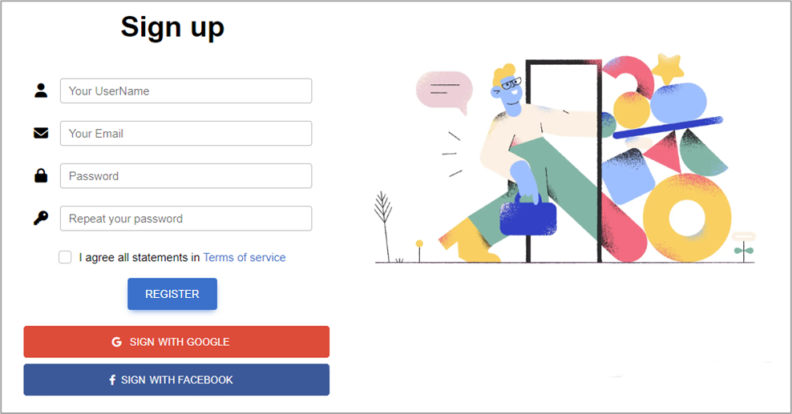

##### 2.2.3. Sign In Page

The **Sign In page** can be reached from the Home page. The page provides fields for **Email and Password**, as well as a **Remember password** option, and a **Sign In button**.

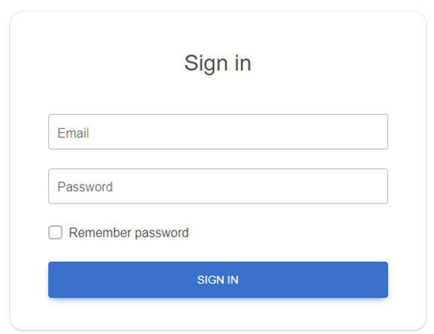

##### 2.2.4. Home Page for logged users

Once a user is **logged in**, they are directed to a different version of **the Home page**. The page includes a **Navbar** with links to **the Home page, My Profile, My Ideas, Create Idea, and a Logout button**. The carousel here includes slides welcoming the user, and offering quick navigation to their profile (**See your profile**) or ideas (**See your ideas**).

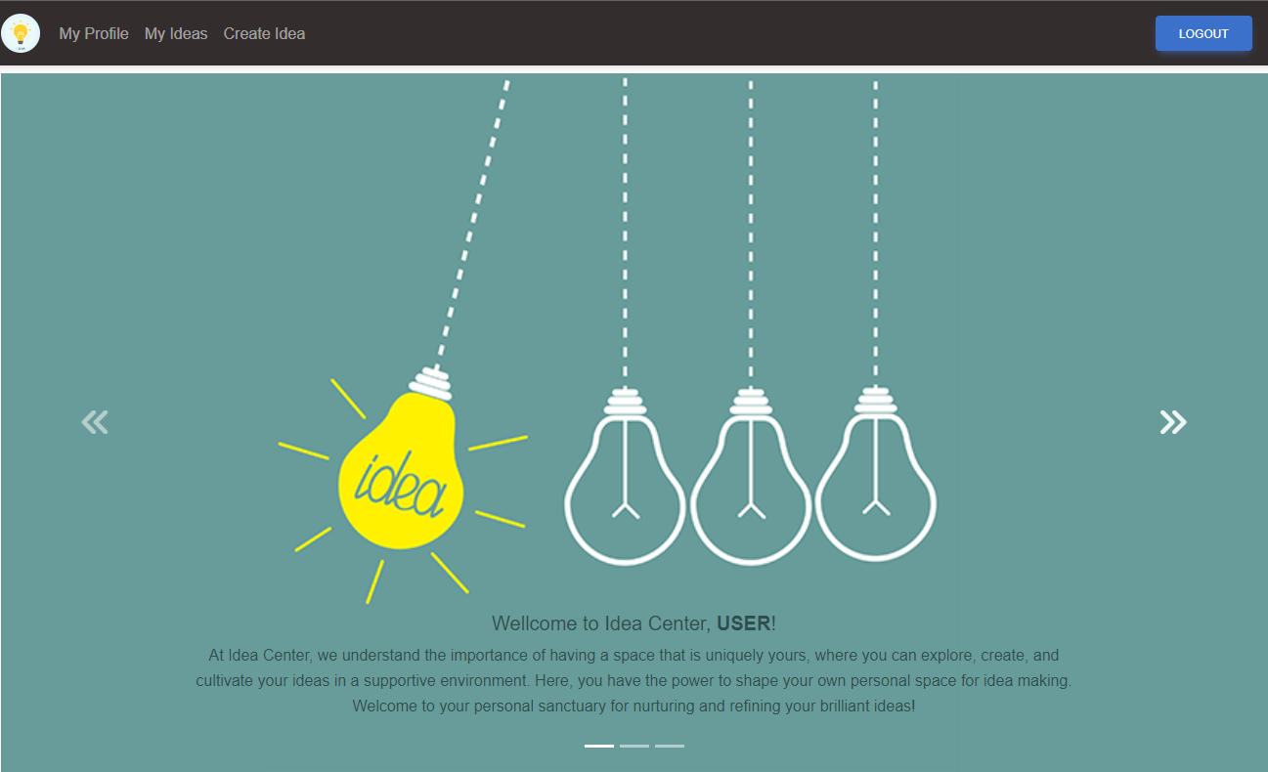

##### 2.2.5. My Profile Page

This page is **accessible to logged users** and includes a **default empty profile picture**, an **Edit profile button**, **an empty About section by default**, and **a counter of the user's ideas**, which is initially set to 0. If no ideas have been created yet, the **Recent ideas section shows** a **No ideas** message. There is also a **Show all link** which leads to **My Ideas page**.

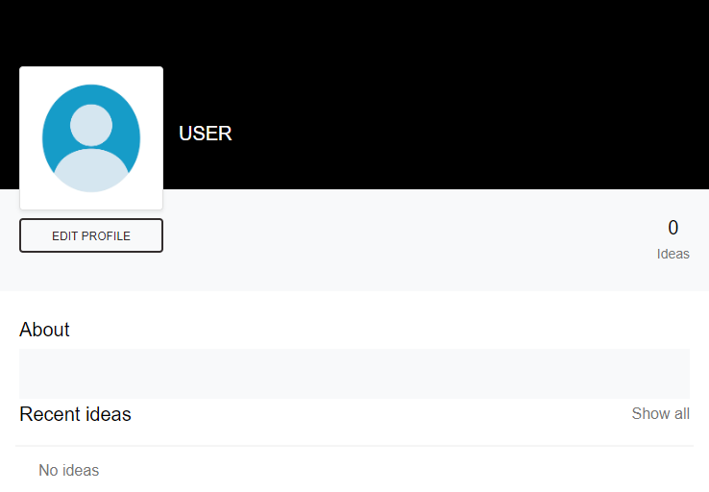

##### 2.2.6. Edit Profile Info Page

Accessible from the **My Profile page**, upon clicking on **EDIT PROFILE button** this page allows **users to** **edit their profile information**, including **Profile picture** (picture is not uploaded, but must be a **valid URL of a picture**), **First name** (max 60 characters length), **Last name** (max. 60 characters length), **City** (max. 120 characters length), and a **Describe yourself** section (max. 256 characters length).

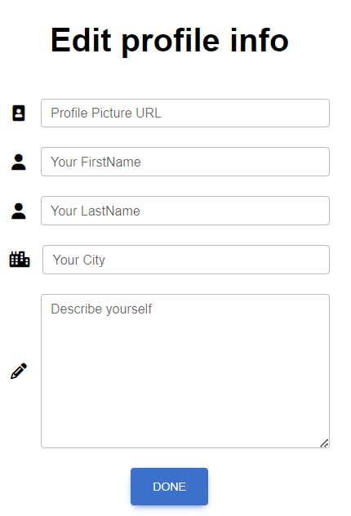

##### 2.2.7. My Ideas Page

This page is accessible **from the Navbar** and contains a **Search ideas field** and a **Search button**. If no ideas have been created yet, a **No ideas yet!** message is displayed.

Users can **enter keywords and click the Search button** to initiate the search. The search functionality then filters the list of ideas based on the provided search terms.

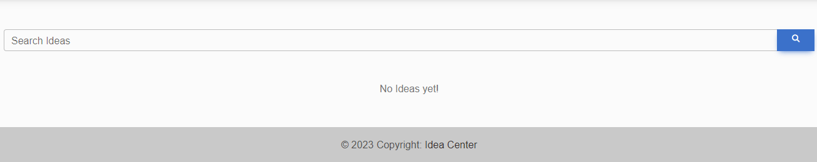

Upon **Creating an idea**, it appears on the **My Ideas page** where the user can **VIEW, EDIT, or DELETE** it.

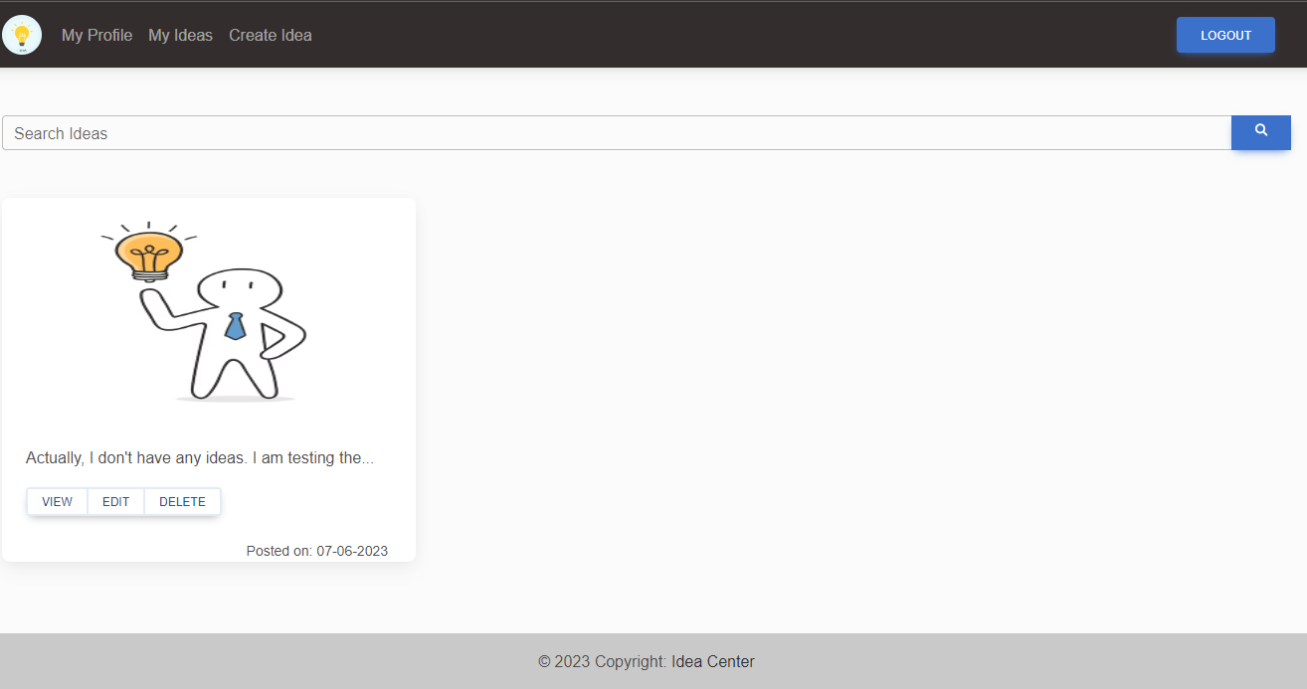

##### 2.2.8. Create Idea Page

This page can be **accessed from the Navbar** and contains fields for **creating a new idea**, including a **Title** (3-70 characters length), **Add picture field** (picture is not uploaded, but must be a valid URL of a picture), and a **Describe your idea field** (3-400 characters length). Title and Description are mandatory. After entering these details, the user can click on the **CREATE button** to save the idea.

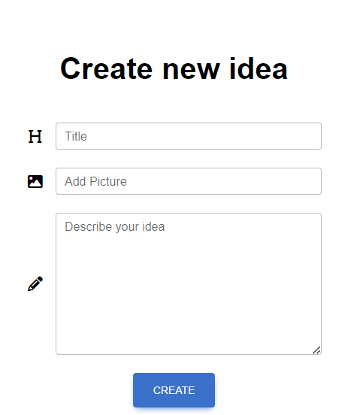

##### 2.2.9. Idea Management

Managing Ideas is **available for all created ideas from My Ideas Page**. Each Idea has three options – **VIEW, EDIT, and DELETE**.

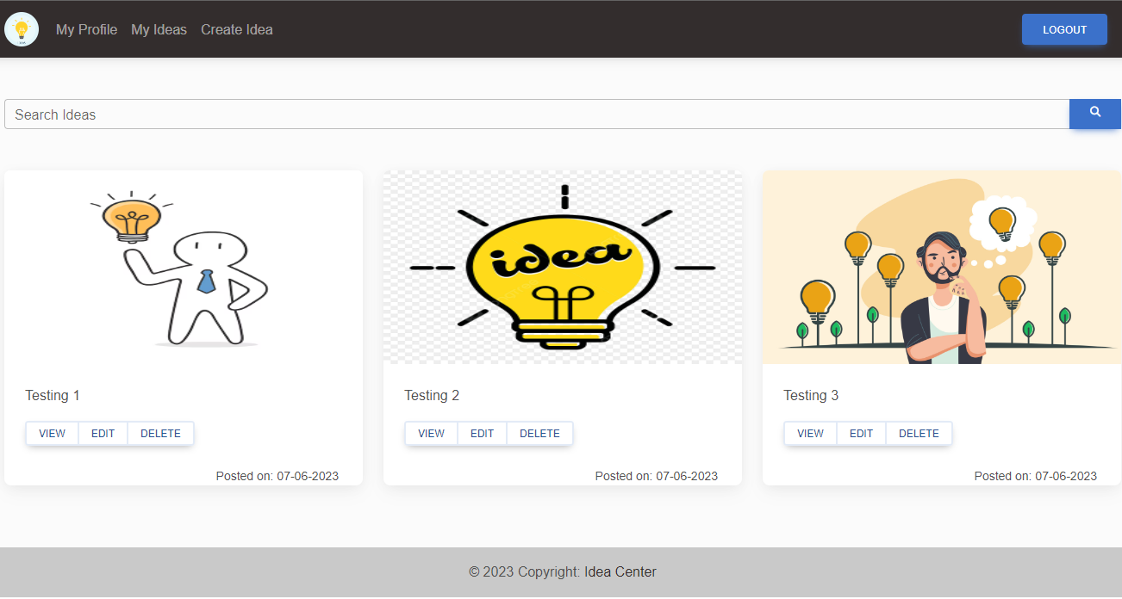

##### а. View

Available after clicking on **VIEW button**.

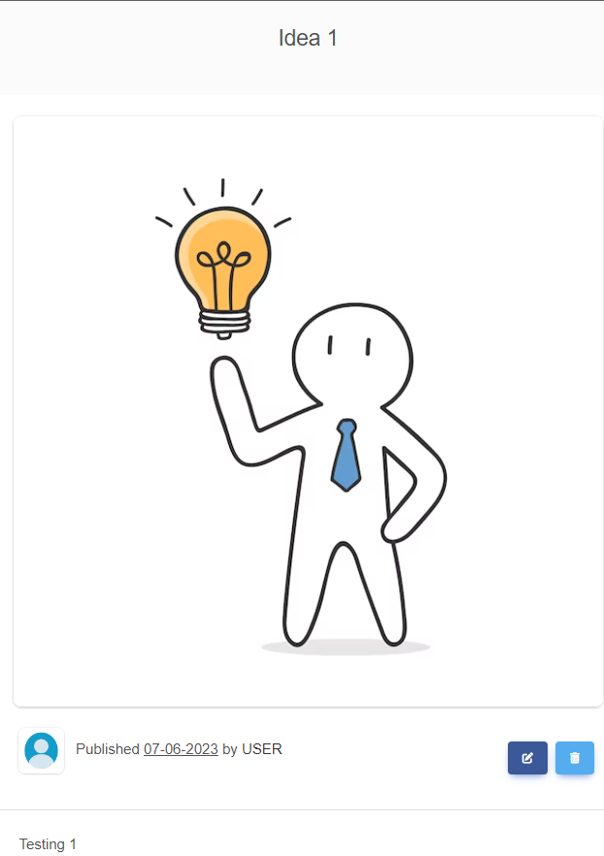

##### b. Edit

Available after clicking on **EDIT button**.

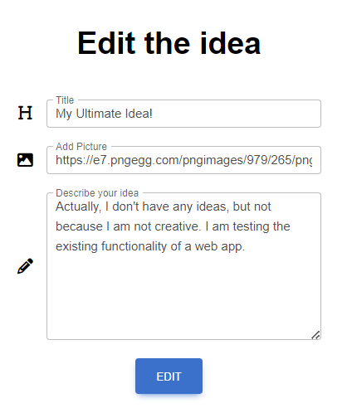

##### c. Delete

After clicking on **DELETE button**, the Idea is deleted and it **disappers from My Ideas Page**.

## Functional Requirements

### 1. Use Case 1 (Home Page)

Users can access The Idea Center **from its designated URL via the internet**, which will load the Home page, Carousel, and Navigation Pane, appropriate to the user's logged-in status (unregistered/non-logged or registered/logged).

### 2. Use Case 2 (User Registration)

**Unregistered users** should be able to successfully go through **the Sign Up process**. This involves the utilization of fields such as Username, Email, and Password, all subject to their respective constraints and character type acceptance. User should have the **option to Sign Up via Facebook or Google** if he prefers.

### 3. Use Case 3 (User Sign In)

**Registered users** should be able to successfully go through the **Sign In process**. They should be able to sign in using Email and Password.

### 4. Use Case 4 (Profile Management)

**Upon successful Sign In, logged users** should be able to navigate to **My Profile page**, edit their Profile details, and **view their Ideas count**. This involves the **changing of profile picture** inserted via URL, and **editing of user data** fields including **First Name, Last Name, City, and Describe Yourself**.

### 5. Use Case 5 (Idea Creation)

**Logged users** should be able to navigate to the **Create Idea page**, where they can create a **New idea with a Title, Picture (URL), and Description**. After the idea creation process, users should be redirected to the My Ideas page, where the newly created idea should be present.

### 6. Use Case 6 (Idea Management)

On the **My Ideas page**, logged users should see **all their ideas listed**. Each idea should have options for **VIEW, EDIT, and DELETE**. If no ideas have been created yet, a **No ideas yet! message** should be displayed. Users also should have the option to search for ideas, based on keywords.

## Idea Center Web App Tasks

### **1. Test Cases**

You need to write **test cases** **for each of the 6 Use cases**.  
**Each Use case** should have at **least 2 Test Cases**.

You should write **at least 15 test cases**.

### 2. Bug Reports

You should find and describe at least **5** bugs.

### 3. Template Use the provided Test-Management-and-Bug-Tracking-Template.xlsx to document your work.